Final Project – Data Structures and Algorithms

Nathaniel Carlson

CS-499

The project I chose for my capstone project is a consultant performance dashboard for the contact center where I work. I built this dashboard myself over a year ago, and have made many updates and improvements since. However, Excel as a data analysis tool has its downsides. The file at this point is rather large and slow because of the large amount of data stored in it, and the number and complexity of the calculations used to generate the necessary results. Additionally, some of the data points used for the metric performance calculations come from other reports, so they are one or two steps removed from the original source data, which increases the chance of errors or discrepancies across various reports. This made a great opportunity to apply my skills in computer science by updating the dashboard to run directly from tables created from the original source programs, and housed in a structured SQL database. This also would allow the final dashboard to be more user friendly, more secure (as the data isn’t housed within the file itself, and Qlik provides user authentication), and more robust in terms of what values can be reported and how easily a user can change scope and apply or remove filters to the data being analyzed.

One of the most important aspects in making the dashboard function properly is the data structure used to organize the tables in a way that allows filters to work properly across all data points, and for metrics calculated from multiple data sources to be calculated efficiently and correctly. I was able to accomplish this by creating a central link table which contained the consultant name, ID and date for all activity within the sample data period. This table also used key fields that were a combination of consultant name and the date represented to create a unique and distinct key to link to each of the fact tables containing data for the various types of interactions and evaluations performed by and for each consultant by date. This resulted in a central link table that could be filtered by date and consultant, and these filters would apply across all of the fact tables containing data about that consultants performance for the selected date or date range.

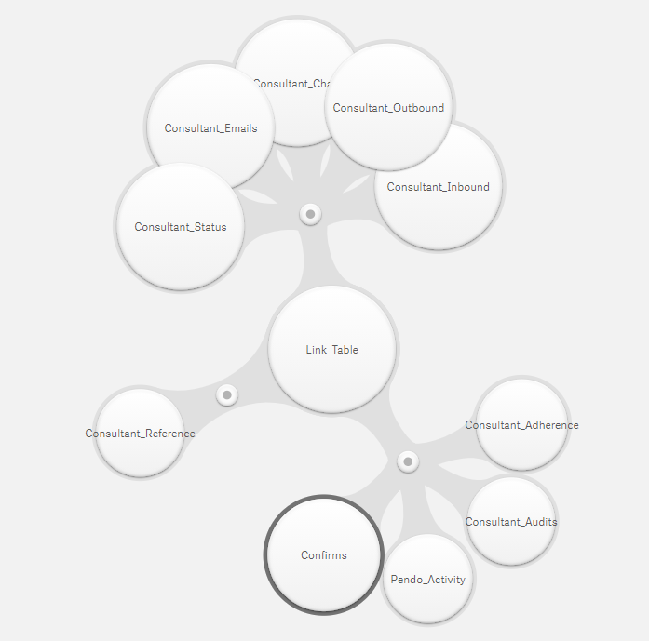

With the data structured this way, I was able to perform the necessary algorithms on the data to calculate each of the necessary consultant KPI metrics.

Some of these metrics were quite simple in their calculations, but by adding additional measures to the calculations, I was able to increase the value of the metrics provided to the user. For example, I initially created a line graph plotting the average inbound phone call handle time for a consultant by date using the function



This is something that was plotted in the initial Excel document on a monthly timescale, but Qlik is easily able to plot this information on a daily scale, and could do so on an even more granular level if I choose to provide the data to do so in the future. In order to provide more value to the user, I also implemented a plotted line that excludes the consultant filter.



By omitting the consultant filter for this plotted line, a user can apply any number of other filters to the data and see how the performance of a particular consultant compared to that of his or her peers for the same time period.

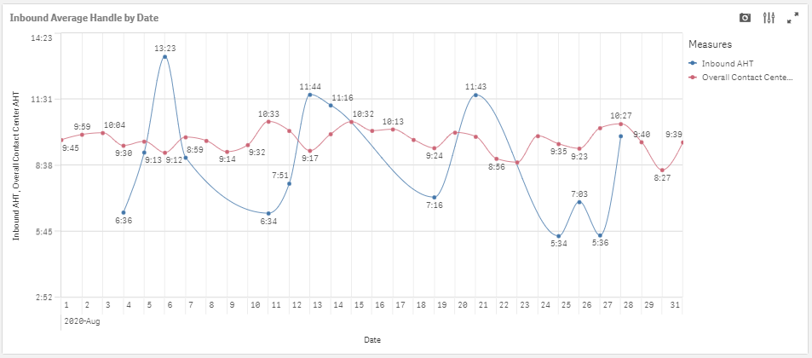

This allows a user to get additional information on how a specific consultant is performing compared to others in the same role and time period and to see how their individual performance trends compare as well. This is functionality well beyond what was available with the previous Excel dashboard and makes it much easier for a supervisor or manager to evaluate a specific consultant’s performance compared to his or her peers.

Another algorithm made possible by the data structure implemented is one that measures the number of cases completed per productive hour by a consultant. This calculation requires raw data from multiple different sources, and previously was calculated from a separate report and then copy and pasted into the Excel dashboard data. With the SQL tables and data schema implemented in Qlik, it is possible to do this within the dashboard itself directly from the raw data sources.



This expression is pulling data from multiple different tables to complete the necessary calculation. The confirm count comes from one table populated from one data source. The cancel, unfilled and unserv counts come from a separate table from a second data source. The counted staffed time is a measure of time a consultant is staffed to work minus the time they are scheduled for breaks, meals, training and other business approved time that a consultant is not expected to be working cases, and is itself a calculated field from a third table, implemented in the data load editor.

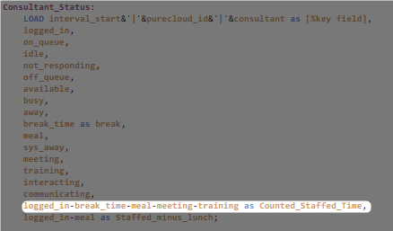

The total inbound handle time is the final variable needed for this calculation, and is a measure of the time a consultant was engaged on inbound calls throughout the day and therefore unable to work on completing cases. By building the data schema correctly, all of these tables can be referenced in a single algorithm to accurately calculate a consultants completes per hour.

A third calculation on the dashboard is a consultants average handle time for inbound calls. This is a simple calculation when looking at an individual day, but when looking at a date range, a weighted average is required.



In Qlik this is rather simple to implement and doesn’t necessitate a SUMPRODUCT function as in Excel. The calculations is fairly straightforward, and Qlik is able to implement this correctly across a given date range to produce the correct result as verified against the existing dashboard.

There are a number of different calculations available on the final dashboard, most of which reference data points from at least two different data sources and which each have their own algorithm.

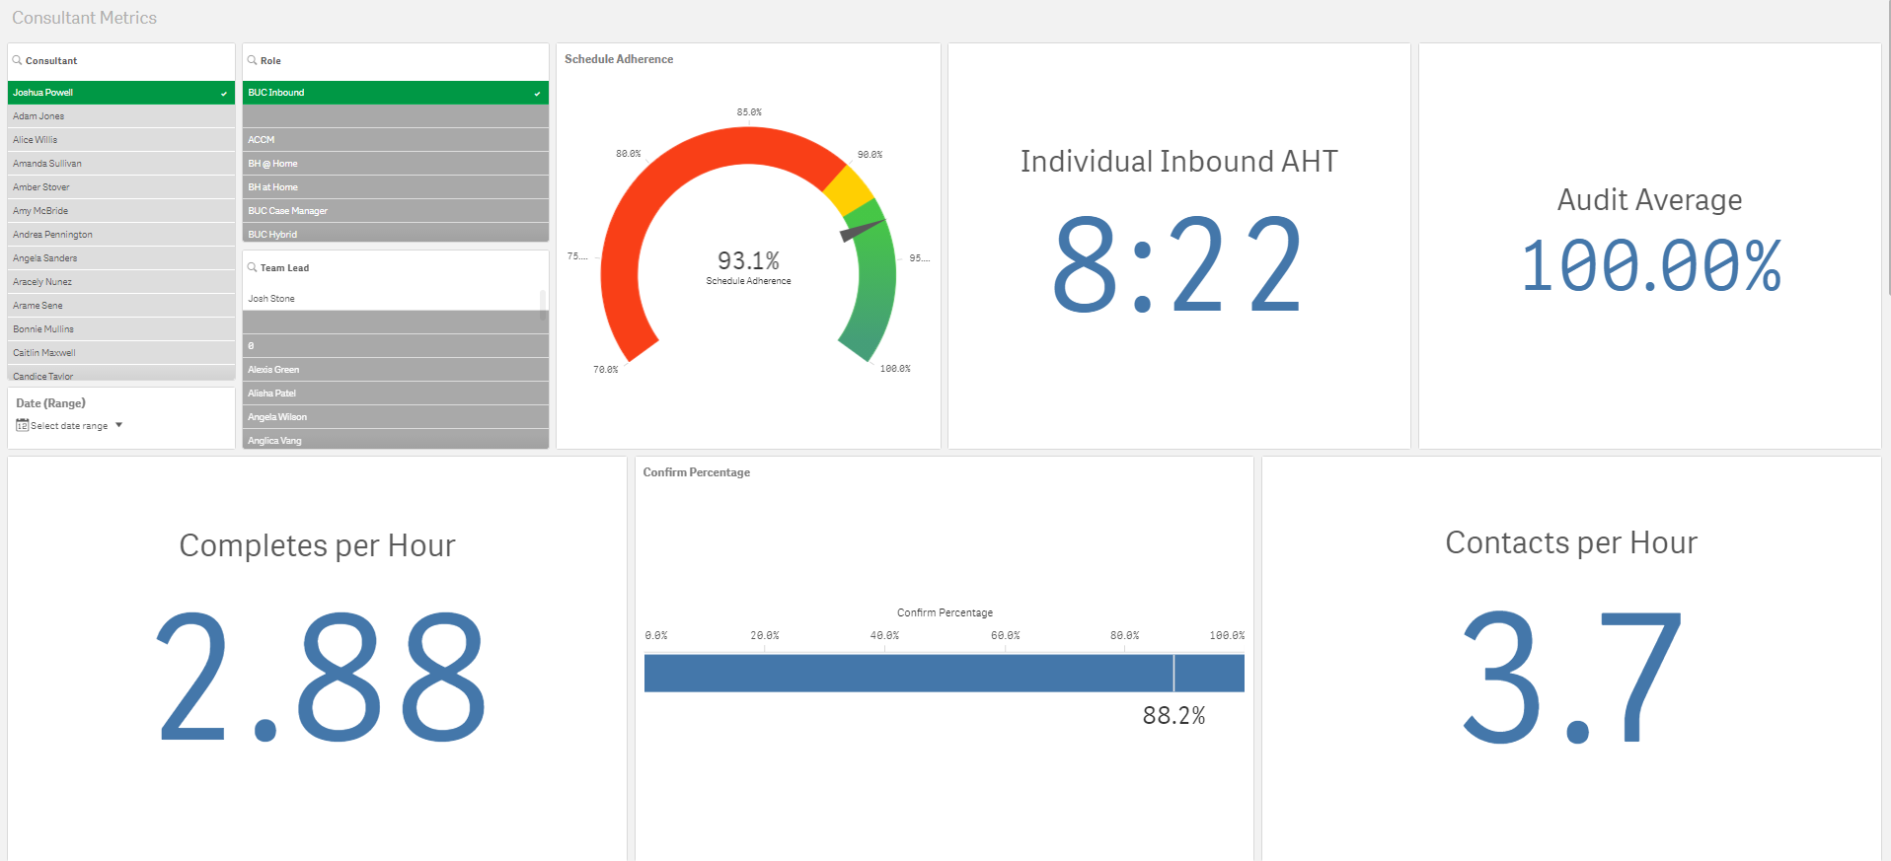

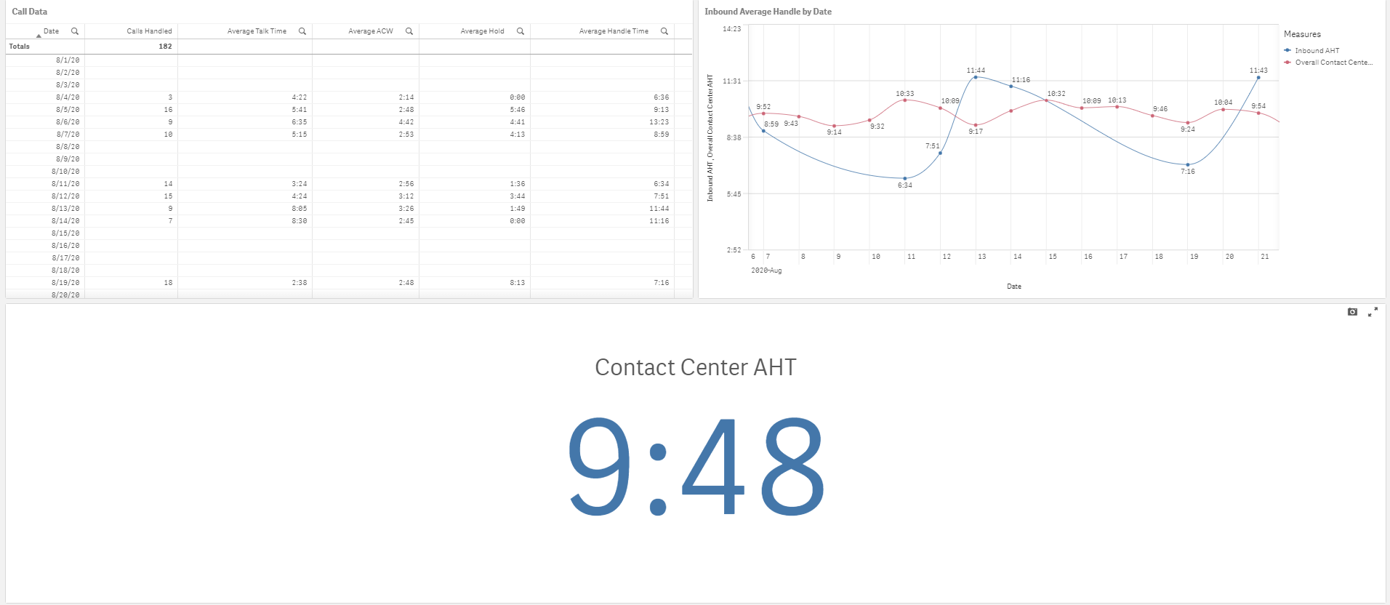

At this point I feel I’ve only scratched the surface of what is possible in terms of analysis and calculation with this data schema and with Qlik. I’ve successfully implemented all of the data points of the initial dashboard, as well as adding additional analysis and insight that wasn’t available in the previous iteration. I will continue to work on formatting and on discovering additional helpful information that will help guide supervisors and managers in the contact center. I also plan to present this to my team, and to work on adding more data to the database, as I currently only have one month of data, which in some tables is incomplete, for testing and development purposes. I also plan to also implement bonus payout calculations into this dashboard, or on a separate one using the same data structure in the near future as well.

The process of creating this dashboard was certainly an enjoyable one. While there were certainly hang ups and frustrations that come with learning a new tool, I am now excited at the prospects of what can be done with Qlik, and how I can use it to provide additional value to the business I support. My biggest struggle came from trying to figure out how to tie together data that had matching consultant names, IDs and dates across multiple tables, but once I learned how to overcome this by creating a link table and compound keys, things became much easier. There were also a few frustrations in learning the syntax for various operations in Qlik, both in the data load editor and in the dashboard itself, but overall the tool is quite intuitive and easy to use.